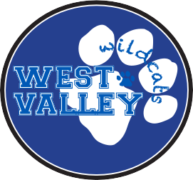
DIRECT DONATION
TOGETHER WE CAN

March 9, 2015

West Valley Community,

This week, we are kicking off our annual Direct Donation Campaign, which funds approximately half of the WVPTO budget for the year. In past years, the Direct Donation Campaign has been used to fund Instructional Aides in the classroom, our library clerk, music enrichment classes, physical education, and technology support, while Walk-a-thon funds raised funded programs such as Family Science Night, Exploration Day, teacher funds for the classroom, Project Cornerstone, the school garden, yearbook, Young Author’s Faire, etc. This year, as we continue to merge WVEEF and PTA operations, all funds raised will be going towards one budget.

Our recent survey shows that West Valley families would like to see PTO funds used in the following ways:

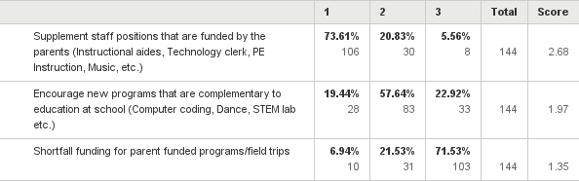

The funds we earned from Walk-a-thon alone will not enable us to fully fund the above goals. 100% of the funding for the programs listed above, and many more, are provided by donations from the West Valley community and corporate matching from many employers. This year, our goal is to raise $110,000 and we need your help! Many programs for the 2015 - 2016 school year are fully dependent on this Direct Donation Campaign.

We strive for 100% participation from all of our West Valley families. The suggested donation is $400 per family with one student, plus $100 for each additional student at West Valley. Please donate what you can - every donation and any amount is appreciated! In addition, you may choose to direct all or a portion of your contribution towards the Endowment Fund to generate interest income and fund longer-term goals.

Payment Options:

- Fill out the form (reverse side) and return it to the WVEEF mailbox in the office with your check
- Donate online via PayPal at http://www.wvpto.org/donation-now.html. Choose a one-time payment or an installment plan over 4 months.

FREQUENTLY ASKED QUESTIONS

Why do I need to contribute?
Many of us choose to live in CUSD for the great public schools, but educational excellence comes at a price. Public funding for schools provides a bare bone baseline program, with no funding for music, libraries, PE instruction, or enrichment activities. To maintain high quality education, the WVPTO asks like-minded parents and community members to fund the enrichment and programs that allow our students to thrive.

Is my donation tax deductible?
Yes! Your donation is tax deductible. The West Valley Educational Endowment Fund (WVEEF) is a 501(c)(3) non-profit organization. Our tax ID# is 77-0491540.

What should I do if I can’t afford the suggested amount?
Every donation makes a difference. Please contribute an amount that fits your budget. It is the many individual donations that collectively add up to the grand total raised each year. We strive for 100% participation.

Public school is supposed to be free. Why should I donate?
State funding barely covers rising expenses and mandated programs. Without WVEEF funding, programs that support additional staffing, as well as our many enrichment and recreational programs, would not be possible.

How do I make a donation?
Payments and payment plan options are available online at http://www.wvpto.org/donation-now.html. You may also donate by check – drop it off in the WVEEF mailbox in the school office or mail to: PO Box 2032, Sunnyvale, CA 94087. Please include the Donor Contribution Form with your check.

What is corporate matching?
Many companies match contributions to non-profit US based 501(c)(3) organizations. This can instantly double your contribution! Ask your HR / Benefits department if your company participates.

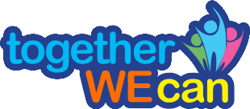
WEST VALLEY DIRECT DONATION DRIVE

DONOR CONTRIBUTION FORM
Parent Name(s) |  | Anonymous Donor
Home Address |  | E-mail:
Children’s Names |  | Grade/Rm:
Payment Method | Check Online Corporate Match | Total Donation Amt:
Choose Your Fund | Operating Fund $ Endowment Fund $

